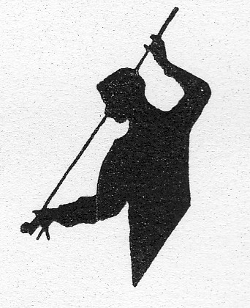

Yorkshire Billiards & Snooker
Association
www.ybsa.co.uk

Yorkshire Snooker Championship 2020

Official Entry Form
Entry Fee £ 18
Qualifiers Best of Five (5) Frames
Quarter-finals to Final Best of Seven (7) Frames
Qualifying dates for the Championship
Choice of 1st MAR or 15th MAR (4 qualify from each)

QUARTER FINALS & SEMI FINALS on 19TH APRIL

FINAL ON FRIDAY 5TH JUNE 2020

Prize money £ 1,000 dependent upon entries

Please enter me for the
2020 ‘Northern Snooker Centre’ Yorkshire Snooker Championship
At The Northern Snooker Centre, Kirkstall Rd, Leeds.
I have made my entry via bank transfer of £ 18
Please note NEW Bank details as follows :
Yorkshire Billiards & Snooker Association
Sort code 05–03-48 Account No. 30241819
When paying by bank transfer please enter your name as reference.
You will still need to send in this completed entry form
Send entry to Richard Bakes via yorkshiresnooker@hotmail.com or via Text / WhatsApp to 07940 651850
My personal details are as entered below:
Name......................................................................................................
Home Address.....................................................................................
...................................................................Post Code...........................
Telephone No. and STD.................................
Registered Club……………………………………………………...
Email Address …………………………………………………
Preferred qualifying date (Choose 1 date) …………………………
DEADLINE FOR ALL ENTRIES IS 2nd FEBRUARY 2020
I have read a copy of the Y.B. & S.A. Rules & Conditions and agree to abide by them

SIGNED .................................................DATE..........................................

